***Soil Vocabulary***

___Soil______- a mixture of weathered rock particles, minerals, decaying organic material, water, and air found on Earth’s surface in which plants can grow

___decomposer________- An organism, often bacteria or fungus, that feeds on and breaks down dead plant or animal matter, turning it into humus.

*Examples—bacteria, mushrooms, worms*

____organic_________-made from once living plant and animals

__compost_________- mixture of decaying organic matter, as from leaves and manure, used to improve soil structure and provide nutrients

___soil horizons__________- Layers of soil that differ in color, texture, and composition (See below)

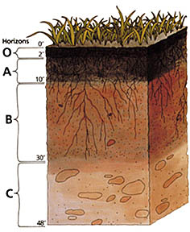***Soil Profile–*** *a vertical section of the soil extending through all its horizons and parent material.*

___humus___________-dark colored substance that forms

as plant and animal remains decay.

___topsoil________- crumbly, dark brown soil that is

a mixture of humus, clay, bits of rock, and other minerals.

*Great for growing plants.

__subsoil______- consists of clay, small rocks broken

up by tree roots, and other particles washed down from

the topsoil. There is very little organic matter in this layer.

____bedrock_______- the solid layer of rock beneath

the soil. Minerals in this rock help determine the type of

soil that forms.

**Soil Formation and Conservation**

**Why is soil a valuable natural resource?** (pg. 98 & 102)

1. Everything that lives on land depends on soil

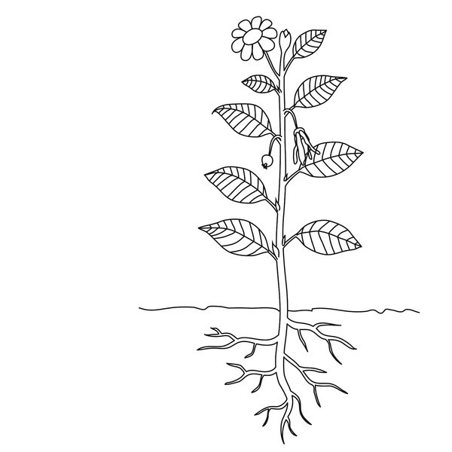 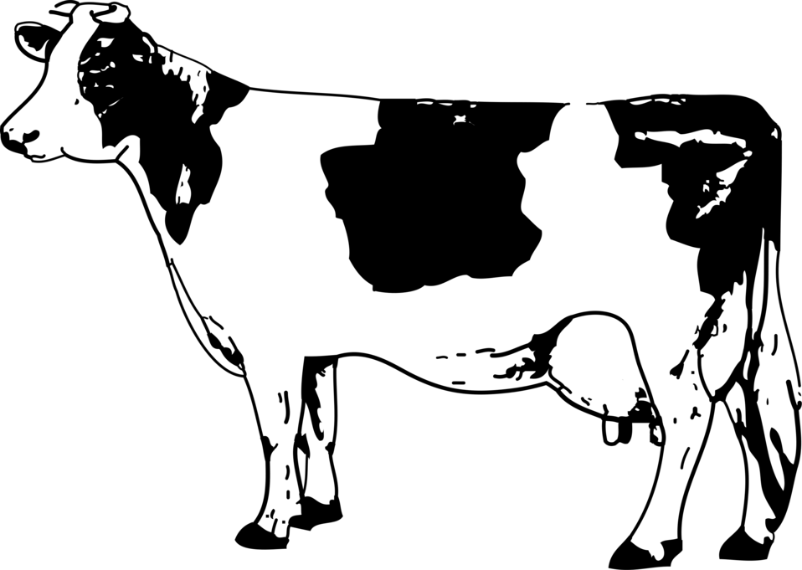 

1. Limited Supply
   1. >1/8 of land on Earth is suitable for farming
2. One inch of topsoil takes ___thousands____ of years to form.

**___soil conservation_________**--the management of soil to limit its destruction (*Example—Dust Bowl) (*pg. 106)

* + ___crop rotation____________--farmers plant different crops in a field each year
  + ___contour plowing________--farmers plow their fields along the curves of a slope instead of straight rows. This helps prevent soil from washing away.
  + ____conservation plowing____--dead weeds and stalks from the previous year’s crop are plowed into the ground to return nutrients and help hold soil in place.



**Weathering:**___the breaking down of rocks and minerals into smaller pieces_______________________

1. ___chemical weathering__________-process that breaks down rock through chemical

changes. (Examples—acid rain, oxidation)

2. ___mechanical weathering______-process in which rock is physically broken into smaller

pieces. (Examples- water, wind, ice, plants)

**4 Factors That Affect Weathering:** (pg. 158)

1. Type of rock

2. Climate

3. Topography

4. Plants and Animals